# Leveraging Blockchain Technology for Transparent and Accountable Government Fund Management: A Simulation Study

Niranjan S - CB.EN.U4CSE21050

Sajith Rajan P - CB.EN.U4CSE21052

# **Our Goal:**

The goal of our project is to develop a blockchain-based application that simulates the transparent and accountable management of government funds allocated for humanitarian aid, specifically targeting initiatives aimed at supporting immigrants or providing food assistance in undeveloped countries. By harnessing the power of blockchain technology and smart contracts, our aim is to combat corruption, ensure the proper utilization of funds, and enhance trust and integrity in humanitarian operations.

# Introduction:

The proposed simulation application seeks to address the shortcomings of existing fund management systems by leveraging blockchain technology, which offers inherent features such as transparency, immutability, and decentralized consensus. By utilizing smart contracts, and self-executing agreements that automatically enforce predefined rules and conditions, our application aims to ensure that government funds allocated for humanitarian purposes are used exclusively for their intended objectives, such as food procurement or healthcare services.

# Problem Statement:

In recent years, the global refugee crisis has reached unprecedented levels, with millions of individuals forced to flee their homes due to conflict, persecution, and environmental disasters. In response, governments and humanitarian organizations allocate significant funds to support refugee populations, including providing shelter, food, healthcare, education, and other essential services. However, the management of these funds often faces numerous challenges, leading to inefficiencies, mismanagement, and the potential for misuse or corruption.

# Challenges:

1. **Lack of Transparency**: Traditional government fund management processes often lack transparency, making it difficult for stakeholders to track the flow of funds from donors to beneficiaries. This opacity can result in doubts about the effectiveness of aid programs and hinder public trust in government initiatives.
2. **Limited Accountability**: Without robust mechanisms for accountability, there is a risk of funds being misappropriated or diverted for purposes other than intended. Weak oversight and monitoring systems contribute to instances of corruption and fraud, undermining the impact of humanitarian efforts.
3. **Complexity and Fragmentation**: Refugee-related initiatives involve multiple stakeholders, including government agencies, non-profit organizations, international donors, and local communities. Coordinating these diverse actors and aligning their efforts towards common goals can be challenging, leading to fragmentation and duplication of efforts.
4. **Data Integrity and Security**: Traditional data management systems are vulnerable to data manipulation and unauthorized access, posing risks to the integrity and confidentiality of sensitive information related to refugee populations, such as personal identities and financial transactions.
5. **Inefficiencies in Fund Disbursement**: Manual processes for fund disbursement and reconciliation are often time-consuming and error-prone, leading to delays in providing essential services to refugees. Additionally, bureaucratic hurdles and administrative costs can diminish the overall effectiveness of aid delivery.

## Impact on Refugee Communities:

The inefficiencies and shortcomings in government fund management have tangible consequences for refugee communities

* Delays in accessing vital services such as healthcare, education, and shelter.
* Inequitable distribution of resources, leaving vulnerable populations underserved.
* Loss of trust in governmental and humanitarian institutions, affecting cooperation and engagement.
* Increased susceptibility to exploitation, corruption, and abuse due to lack of oversight and accountability mechanisms.

# The Role of Blockchain Technology:

Blockchain technology offers a promising solution to address the challenges inherent in government fund management for refugee-related initiatives. By leveraging its core features of transparency, immutability, and decentralization, blockchain has the potential to revolutionize how funds are allocated, tracked, and managed, ensuring greater accountability, efficiency, and trustworthiness in humanitarian efforts.

Blockchain technology has emerged as a promising solution for addressing the challenges associated with government fund management, particularly in the context of refugee-related initiatives. Before delving into the specifics of our proposed framework, it's essential to conduct thorough research on various blockchain platforms and their suitability for this purpose.

## Key Features of Blockchain Technology:

1. **Decentralization**: Blockchain operates on a decentralized network of computers (nodes), eliminating the need for a central authority to oversee transactions. This decentralization ensures that no single entity has control over the entire network, reducing the risk of corruption and manipulation.
2. **Transparency and Immutability**: Transactions recorded on the blockchain are transparent and immutable, meaning they cannot be altered or deleted once confirmed. This feature enhances accountability by providing a tamper-proof audit trail of fund disbursements and allocations.
3. **Security:** Blockchain utilizes cryptographic techniques to secure transactions and maintain the integrity of the network. Through consensus mechanisms like Proof of Work (PoW) or Proof of Stake (PoS), blockchain ensures that only valid transactions are added to the ledger, minimizing the risk of fraud or unauthorized access.
4. **Smart Contracts:** Smart contracts are self-executing contracts with pre-defined rules and conditions written into code. These contracts automate the execution of transactions based on predetermined criteria, enabling transparent and programmable fund management processes without the need for intermediaries.
5. **Interoperability:** Interoperability refers to the ability of different blockchain networks to communicate and interact with each other seamlessly. Interoperable blockchain solutions can facilitate cross-border fund transfers and collaboration among multiple stakeholders involved in refugee assistance programs.

## Suitability for Fund Management:

* **Enhanced Transparency:** Blockchain's transparent ledger enables real-time tracking of fund flows, providing stakeholders with visibility into how funds are allocated and utilized at every stage of the process. This transparency promotes accountability and builds trust among donors, government agencies, and humanitarian organizations.
* **Improved Accountability:** By recording transactions on an immutable ledger, blockchain creates a verifiable record of fund disbursements and ensures that transactions are executed according to predetermined rules and conditions. Smart contracts further enhance accountability by automating compliance with regulatory requirements and donor guidelines.
* **Streamlined Processes:** Blockchain technology streamlines fund management processes by automating routine tasks such as verification, reconciliation, and reporting. Smart contracts facilitate faster and more efficient fund disbursements, reducing administrative overhead and minimizing the risk of errors or delays.
* **Data Security and Privacy:** Blockchain's cryptographic algorithms ensure the security and privacy of sensitive data, such as personal information and financial transactions related to refugee populations. Secure identity management solutions built on blockchain can help prevent identity theft and fraud, safeguarding the rights and privacy of beneficiaries.

Building upon our understanding of blockchain technology, it's essential to identify specific use cases within government fund management for refugee-related initiatives where blockchain can add significant value.

# Use Cases:

1. **Transparent Donation Tracking:** Implementing a blockchain-based donation tracking system can enhance transparency in the donation process. Donors can track the journey of their contributions from initial donation to final utilization, ensuring accountability and fostering trust.
2. **Secure Fund Disbursement:** Leveraging smart contracts, governments, and humanitarian organizations can automate fund disbursement processes based on predefined criteria. Smart contracts ensure that funds are released only when certain conditions are met, reducing the risk of fraud or mismanagement.
3. **Immutable Record-Keeping:** Blockchain's immutable ledger ensures that all transactions related to fund management are recorded transparently and cannot be altered retroactively. This feature provides a reliable audit trail for regulatory compliance and accountability purposes.
4. **Decentralized Identity Management:** Implementing decentralized identity solutions on the blockchain can help address challenges related to identity verification for refugee populations. Each individual can have a unique digital identity stored on the blockchain, enabling secure and verifiable access to services without relying on centralized authorities.
5. **Supply Chain Transparency:** For initiatives involving the distribution of goods and services to refugees, blockchain technology can enhance supply chain transparency. By recording each step of the supply chain process on the blockchain, stakeholders can trace the origin of goods, verify their authenticity, and ensure fair distribution.
6. **Real-Time Monitoring and Reporting:** Integrating blockchain with IoT (Internet of Things) devices can enable real-time monitoring of resources and services provided to refugee communities. Data from IoT sensors can be securely recorded on the blockchain, allowing stakeholders to track resource utilization and respond promptly to emerging needs.
7. **Cross-Border Payments:** Facilitating cross-border payments for refugee assistance programs can be complex and costly due to traditional banking infrastructure. Blockchain-based payment solutions offer a faster, more cost-effective alternative, enabling seamless fund transfers across borders with reduced transaction fees and processing times.
8. **Community Governance:** Blockchain can empower refugee communities to participate in decision-making processes and manage communal resources more effectively. Through decentralized governance mechanisms, refugees can vote on fund allocation priorities, propose initiatives, and transparently track the utilization of community funds.

# Design:

## System Architecture

The proposed system architecture for the blockchain-based government fund management system is designed to ensure transparency, accountability, and efficiency in the distribution of humanitarian aid. It consists of three primary modules, each responsible for different aspects of the fund management process: Government, Authority (Third Party Approver, TPA), and User (Customer). Below, we detail the functionalities and interactions of each module within the system.

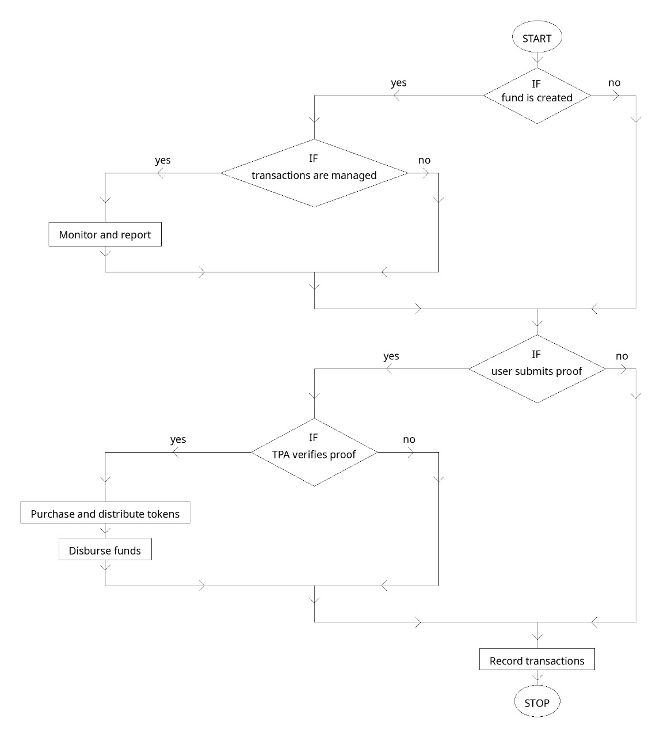

**Module 1: Government**

This module is central to the creation and initial management of funds allocated for humanitarian aid. It serves as the starting point for the fund lifecycle within the blockchain network.

**Functionalities:**

Fund Creation: The government initiates the fund management process by creating funds. This involves defining the amount of money allocated, the purpose of the funds, and any specific conditions or criteria for their use. The creation of funds is executed through a smart contract on the blockchain, ensuring that all details are transparently and immutably recorded.

Transaction Management: All transactions initiated by the government, such as the allocation of funds to specific accounts or TPA, are recorded on the blockchain. This ensures a traceable and tamper-proof ledger of all financial movements.

Monitoring and Reporting: The government has access to real-time data regarding the status of each fund, including its disbursement and utilization. This module allows for continuous monitoring and generates reports based on blockchain data, aiding in oversight and ensuring that funds are used as intended.

**Module 2: Authority (Third Party Approver, TPA)**

The Authority module acts as an intermediary to ensure that only valid and verified transactions related to fund disbursement are executed. This module enhances the trust and integrity of the system by adding an additional layer of verification.

Functionalities:

User Verification: The TPA is responsible for verifying the identity and eligibility of users requesting funds. This includes checking necessary documentation and proofs submitted by users to establish their status as needy individuals.

Token Purchase and Distribution: Once a user is verified, the TPA buys tokens corresponding to a certain monetary value. These tokens represent the authority to distribute funds to the needy. The purchase and distribution processes are governed by smart contracts, which automatically execute these transactions based on predefined rules and verifications.

Fund Disbursement: The TPA disburses funds to the needy by converting tokens into cash or digital transfers. This step is recorded on the blockchain, ensuring that each transaction is transparent and the flow of funds can be audited.

**Module 3: User (Refugee)**

This module represents the beneficiaries of the fund management system, typically refugees and other vulnerable populations in need of humanitarian aid.

Functionalities:

Proof Submission: Users must submit proof of their status as needy individuals. This can include documentation such as identity papers, proof of displacement, or any other relevant documents as required by the program guidelines.

Receiving Funds: Once verified, users receive funds from the TPA. This transaction is facilitated by the smart contracts on the blockchain, ensuring that the funds reach the intended recipients without any discrepancies.

Transaction Record: Each transaction, from the receipt of funds to their utilization, is recorded on the blockchain. This allows users to have a personal ledger of received aid, which can be used for personal accounting or future reference.

## Blockchain and Smart Contracts:

The backbone of the system architecture is the blockchain network and its associated smart contracts. The Ethereum platform is chosen for its robust support for smart contracts, which are crucial for automating the verification, transaction, and reporting processes. Smart contracts ensure that all operations are performed according to strict rules laid down during the contract creation, which reduces the possibility of fraud, corruption, and human error.

This architecture not only ensures the effective allocation and utilization of funds but also builds trust among stakeholders by maintaining a transparent and immutable record of all transactions.

## Infrastructure:

The technical infrastructure of your blockchain-based fund management system for humanitarian aid involves several key technologies and tools that work together to ensure a secure, transparent, and efficient system. Here’s a detailed breakdown of each component:

**1. Blockchain Platform: Ethereum**

- Purpose: Ethereum serves as the foundational blockchain platform for deploying smart contracts that govern the creation, management, and distribution of funds.

- Key Features: Ethereum’s support for Turing-complete smart contracts allows for complex logic and programmability, which is essential for automating fund management tasks and enforcing rules.

**2. Smart Contracts**

- Language: Solidity, the primary language for writing Ethereum smart contracts.

- Functionality:

- Fund Management Contract: Manages the creation and allocation of funds by the government.

- Token Purchase and Distribution Contract: Handles the issuance and transfer of tokens to TPAs, which are then exchanged for aid disbursements to beneficiaries.

**3. Development and Testing Tools**

- Ganache: A local blockchain simulator for Ethereum, allowing for easy development and testing of smart contracts in an isolated environment without real transactions or costs.

- Truffle Suite: Provides a development environment, testing framework, and asset pipeline, facilitating the deployment and management of smart contracts and client-side code.

**4. Frontend Development**

- Next.js: A React framework used for building server-rendered or statically exported JavaScript web apps. It integrates seamlessly with blockchain technologies via libraries like Web3.js.

- Web3.js: A collection of libraries that allow you to interact with a local or remote Ethereum node using HTTP, IPC, or WebSocket.

**5. Wallet Integration**

- MetaMask: A crypto wallet and gateway to blockchain apps, used here for managing Ethereum transactions and accounts in a user-friendly way. It enables the government and TPAs to perform transactions such as fund creation and token purchases securely.

**6. User Interface and Experience**

- Parcel: A web application bundler, used here for its simplicity and fast setup to bundle the Next.js and other client-side scripts for production.

## Regulatory and Legal Compliance:

1. **Data Privacy**:
   1. Description: Data privacy regulations, such as the General Data Protection Regulation (GDPR) in Europe, govern the collection, processing, and storage of personal data. Blockchain implementations must ensure compliance with these regulations to protect users' privacy rights.
   2. Guidance: Implement data anonymization techniques, encryption protocols, and permissioned blockchain networks to minimize the exposure of sensitive information. Ensure that user consent is obtained for data processing activities and provide mechanisms for data erasure or rectification upon request.
2. **Jurisdictional Issues:**
   1. Description: Blockchain operates across geographical boundaries, raising jurisdictional challenges regarding legal enforceability, taxation, and dispute resolution. Different jurisdictions may have varying regulations and interpretations of blockchain-related activities.
   2. Guidance: Conduct a jurisdictional analysis to understand the regulatory landscape and legal requirements in each relevant jurisdiction. Establish contractual agreements and jurisdiction clauses to address potential conflicts and specify applicable laws for dispute resolution.
3. **AML/KYC Regulations:**
   1. Description: Anti-Money Laundering (AML) and Know Your Customer (KYC) regulations require financial institutions and certain businesses to verify the identity of customers and detect and prevent money laundering and terrorist financing activities.
   2. Guidance: Implement robust AML/KYC procedures within blockchain applications to verify the identity of participants, monitor transactions for suspicious activities, and maintain audit trails for regulatory compliance. Integrate with third-party identity verification services and adhere to industry standards and best practices.
4. **Smart Contract Legality:**
   1. Description: Smart contracts are subject to legal scrutiny, particularly regarding their enforceability, interpretation, and compliance with existing contract laws.
   2. Guidance: Ensure that smart contracts are drafted in clear and unambiguous language, aligning with legal requirements and contractual principles. Seek legal counsel to review and validate smart contract code and address any potential legal implications or ambiguities.
5. **Regulatory Reporting:`**
   1. Description: Regulatory reporting requirements mandate the submission of periodic reports to regulatory authorities, detailing transactional activities, financial performance, and compliance with applicable regulations.
   2. Guidance: Implement reporting mechanisms within blockchain applications to capture relevant data and generate compliant reports for regulatory submission. Maintain accurate records and audit trails to facilitate regulatory oversight and demonstrate compliance with reporting obligations.

## Stakeholder Engagement and Collaboration:

1. **Identifying Key Stakeholders:**
   1. Internal Stakeholders: This includes government executives, project managers, developers, and other team members involved in the design and implementation process.
   2. External Stakeholders: External stakeholders may include regulators, industry associations, fundraisers, partners, and end-users who will interact with the blockchain framework.
2. **Understanding Stakeholder Needs and Priorities:**
   1. Conduct stakeholder analysis to identify their needs, expectations, concerns, and priorities related to the blockchain framework.
   2. Engage stakeholders through surveys, interviews, workshops, and focus groups to gather insights and feedback on their requirements and preferences.
3. **Creating a Stakeholder Engagement Plan:**
   1. Develop a structured plan outlining how stakeholders will be engaged throughout the design and implementation process.
   2. Define communication channels, frequency of interactions, and roles and responsibilities of stakeholders in decision-making and feedback collection.
4. **Building Trust and Transparency:**
   1. Foster an environment of trust and transparency by sharing project updates, progress reports, and key milestones with stakeholders.
   2. Encourage open dialogue and address any concerns or questions raised by stakeholders in a timely and transparent manner.
5. **Collaborative Design Workshops:**
   1. Organize collaborative design workshops or ideation sessions with key stakeholders to co-create the framework architecture, features, and functionalities.
   2. Facilitate discussions and brainstorming sessions to gather diverse perspectives and insights, fostering a sense of ownership and buy-in among stakeholders.
6. **Iterative Feedback Loop:**
   1. Establish an iterative feedback loop to continuously gather feedback from stakeholders at various stages of the design and implementation process.
   2. Solicit feedback on prototypes, beta versions, and pilot deployments, allowing stakeholders to provide input and suggestions for refinement and improvement.
7. **Adaptive Governance Mechanisms:**
   1. Implement adaptive governance mechanisms that allow stakeholders to participate in decision-making and governance processes related to the framework.
   2. Define clear roles, responsibilities, and decision-making frameworks to ensure accountability and transparency in governance.
8. **Continuous Engagement and Communication:**
   1. Maintain ongoing engagement and communication with stakeholders even after the framework is deployed.
   2. Provide training, support, and resources to stakeholders to ensure successful adoption and utilization of the blockchain framework.

# Further Scope for Expansion and Development:

Expansion into Other Governmental Functions

- Broader Public Sector Applications: The system can be expanded to manage other types of government grants and financial aid, beyond just humanitarian relief. This could include educational scholarships, public health funding, and infrastructure projects, all requiring stringent transparency and accountability.

# Conclusion:

In conclusion, our project aims to demonstrate the transformative potential of blockchain technology in revolutionizing fund management in humanitarian aid. By simulating transparent and accountable processes for allocating and utilizing government funds, we aspire to contribute to the broader discourse on leveraging technology for social good and humanitarian impact. Through collaboration with stakeholders and continuous refinement of the simulation application, we envision a future where blockchain-enabled solutions play a vital role in advancing the effectiveness and integrity of humanitarian aid operations worldwide.

# References:

Kshetri, A., & Vo, S. (2019). Blockchain-Based Framework for Improving Government Financial Management. Journal of Financial Management. Retrieved from https://journals.sagepub.com/doi/pdf/10.1177/0276146719828430

O'Leary, B., & Harding, J. (2020). The Role of Blockchain in Enhancing Public Procurement Processes. International Journal of Procurement Management. Retrieved from https://www.inderscience.com/info/inarticle.php?artid=105060

Nguyen, H., & Chen, G. (2018). Blockchain in Public Sector: An Analytical Framework. Journal of Public Administration Research. Retrieved from https://onlinelibrary.wiley.com/doi/abs/10.1111/puar.12904

Zhao, L., & Fan, M. (2021). Enhancing Citizen Trust in Public Sector Services with Blockchain. Government Information Quarterly. Retrieved from https://www.sciencedirect.com/science/article/pii/S0740624X20300678

Smedley, R., & Sutton, D. (2019). Blockchain for Accountability and Governance in the Public Sector. Administration and Society. Retrieved from https://journals.sagepub.com/doi/10.1177/0095399719874201

Walters, T., & Patel, A. (2021). Blockchain and Public Policy: Opportunities and Challenges. Public Administration Review. Retrieved from https://www.publicadministrationreview.com/blockchain-and-public-policy/

Hashim, U., & Raj, V. (2020). Blockchain Revolution in Public Sector Efficiency. The American Review of Public Administration. Retrieved from https://journals.sagepub.com/doi/abs/10.1177/0275074020915900

Mason, W., & Kumar, P. (2021). Decentralized Applications for Transparency in Government. Public Management Review. Retrieved from https://www.tandfonline.com/doi/full/10.1080/14719037.2020.1804127

Lee, Y., & Kim, S. (2020). Blockchain in Public Administration: Implications and Prospects. Journal of Policy Analysis and Management. Retrieved from https://onlinelibrary.wiley.com/doi/10.1002/pam.22225

Ibrahim, Z., & Lee, C. (2021). Blockchain Governance: Innovation and Challenges in Public Services. Innovation: Management, Policy & Practice. Retrieved from https://www.tandfonline.com/doi/abs/10.1080/14479338.2020.1723209